Supplementary Materials
AI-Assisted Systematic Optimization of the LAMMPS Molecular Dynamics Simulator via Large Language Model Coding Agents
Chun-Yeol You

Contents
- Supplementary Table S1: Complete list of 35 new OMP pair variants
- Supplementary Table S2: A-3 restrict/fxtmp modification log (102 files, representative entries)
- Supplementary Table S3: OPLS-AA force field parameters used in FEP Case Study
- Supplementary Table S4: Li⁺ Joung–Cheatham parameters and Lorentz–Berthelot mixed coefficients
- Supplementary Table S5: OPLS-AA FEP dU/dλ by lambda window (all solvents)
- Supplementary Table S6: A-3 restrict/fxtmp optimization scope by category
- Supplementary Table S7: A-3 before/after performance benchmarks (three representative styles)
- Supplementary Methods S1: Claude Code prompt templates (OMP port generation)
- Supplementary Methods S2: OPLS-AA system construction and FEP protocol
- Supplementary Figure S1: Full OMP scaling benchmarks for new styles
- Supplementary Figure S2: NVE energy conservation comparison
- Supplementary Figure S3: A-3 code transformation (before/after pair hotloop)

Supplementary Table S1: Complete List of 35 New OMP Pair Variants
All styles below were generated by Claude Code, compiled with zero new MSVC warnings, and verified bit-identical to their serial counterparts by a 50-step NVE thermo comparison (thermo_modify format float %20.15g). Files are located in src/OPENMP/ with the naming convention pair_[style_name]_omp.{h,cpp}.
# | Package | Standard style | OMP variant | Loop type | New register in eval<>
1 | EXTRA-PAIR | lj/cut/soft | lj/cut/soft/omp | half-Newton | –
2 | EXTRA-PAIR | lj/cut/coul/long/soft | lj/cut/coul/long/soft/omp | half-Newton | –
3 | EXTRA-PAIR | lj/class2/soft | lj/class2/soft/omp | half-Newton | –
4 | EXTRA-PAIR | lj/cut/coul/cut/soft | lj/cut/coul/cut/soft/omp | half-Newton | –
5 | EXTRA-PAIR | lj/cut/coul/dsf/soft | lj/cut/coul/dsf/soft/omp | half-Newton | –
6 | EXTRA-PAIR | morse/soft | morse/soft/omp | half-Newton | –
7 | EXTRA-PAIR | coul/cut/soft/gapsys | coul/cut/soft/gapsys/omp | half-Newton | –
8 | EXTRA-PAIR | nm/cut/split | nm/cut/split/omp | half-Newton | –
9 | EXTRA-PAIR | born/coul/dsf | born/coul/dsf/omp | half-Newton | –
10 | EXTRA-PAIR | born/coul/wolf/cs | born/coul/wolf/cs/omp | half-Newton | –
11 | EXTRA-PAIR | bpm/spring | bpm/spring/omp | half-Newton | –
12 | EXTRA-PAIR | dpd/fdt | dpd/fdt/omp | half-Newton | random seed/thr
13 | EXTRA-PAIR | dpd/fdt/energy | dpd/fdt/energy/omp | half-Newton | random seed/thr
14 | EXTRA-PAIR | lj/relres/soft | lj/relres/soft/omp | half-Newton | –
15 | EXTRA-PAIR | coul/diel | coul/diel/omp | half-Newton | –
16 | EXTRA-PAIR | momb | momb/omp | half-Newton | –
17 | EXTRA-PAIR | coul/streitz | coul/streitz/omp | half-Newton | charge_thr buf
18 | EXTRA-PAIR | extep | extep/omp | half-Newton | –
19 | DIELECTRIC | lj/cut/coul/cut/dielectric | lj/cut/coul/cut/dielectric/omp | full (no Newton) | ef_tally_thr
20 | DIELECTRIC | lj/cut/coul/long/dielectric | lj/cut/coul/long/dielectric/omp | full (no Newton) | ef_tally_thr
21 | DIELECTRIC | lj/cut/coul/msm/dielectric | lj/cut/coul/msm/dielectric/omp | full (no Newton) | ef_tally_thr
22 | DIELECTRIC | coul/long/dielectric | coul/long/dielectric/omp | full (no Newton) | ef_tally_thr
23 | DIELECTRIC | lj/long/coul/long/dielectric | lj/long/coul/long/dielectric/omp | full (no Newton) | ef_tally_thr
24 | DIELECTRIC | lj/cut/coul/debye/dielectric | lj/cut/coul/debye/dielectric/omp | full (no Newton) | ef_tally_thr
25 | DIELECTRIC | coul/cut/dielectric | coul/cut/dielectric/omp | full (no Newton) | ef_tally_thr
26 | KSPACE | lj/long/coul/long | lj/long/coul/long/omp | half-Newton | –
27 | KSPACE | buck/long/coul/long | buck/long/coul/long/omp | half-Newton | –
28 | KSPACE | lj/long/tip4p/long | lj/long/tip4p/long/omp | half-Newton | tip4p_h_thr
29 | KSPACE | lj/cut/tip4p/long | lj/cut/tip4p/long/omp | half-Newton | tip4p_h_thr
30 | KSPACE | lj/long/dipole/long | lj/long/dipole/long/omp | half-Newton | –
31 | EXTRA-PAIR | buck/coul/cut/soft | buck/coul/cut/soft/omp | half-Newton | –
32 | EXTRA-PAIR | buck/coul/long/soft | buck/coul/long/soft/omp | half-Newton | –
33 | EXTRA-PAIR | lj/charmm/coul/long/soft | lj/charmm/coul/long/soft/omp | half-Newton | –
34 | EXTRA-PAIR | lj/charmm/coul/charmm/soft | lj/charmm/coul/charmm/soft/omp | half-Newton | –
35 | EXTRA-PAIR | coul/ctip | coul/ctip/omp | half-Newton | charge_iter_thr

Notes:
- Loop type "full": DIELECTRIC styles use a full neighbor list (all neighbors i→j, not half-list) because the dielectric boundary condition requires summing contributions from all neighbors of i. No Newton's third law write-back is applied.
- ef_tally_thr: The ef_tally_thr() function (added to src/OPENMP/thr_omp.h) accumulates per-thread electric field contributions efield[i][k] in addition to energy/virial.
- tip4p_h_thr: For TIP4P water, the hydrogen force redistribution (from the virtual M-site) is thread-safe only with per-thread hydrogen force buffers.
- random seed/thr: DPD stochastic forces use per-thread random number generators seeded with seed + thread_id to ensure deterministic but uncorrelated thread-local sequences.

Supplementary Table S2: A-3 Modification Log (Representative Subset)
Full log contains 102 entries. Representative entries spanning each category:
File | Category | Modification | Bit-identical | Pair improvement
pair_lj_cut.cpp | Simple LJ | _noalias + fxtmp/fytmp/fztmp | ✓ | +4.2% (4k FCC)
pair_lj_expand.cpp | Simple LJ | same | ✓ | +3.8%
pair_coul_cut.cpp | Simple Coulomb | same | ✓ | +4.1%
pair_coul_wolf.cpp | Composite Coul | same | ✓ | +5.2%
pair_born_coul_dsf.cpp | Composite Coul | same | ✓ | +5.7%
pair_born_coul_wolf_cs.cpp | Composite Coul | same | ✓ | +4.9%
pair_lj_long_coul_long.cpp | Long-range | same (only real-space loop) | ✓ | +3.5%
pair_lj_cut_coul_long_dielectric.cpp | DIELECTRIC | same + ef_tmp for field accum | ✓ | +4.0%
pair_momb.cpp | Specialty | same | ✓ | +7.5%
pair_coul_ctip.cpp | Charge-iter | same (inner pair loop only) | ✓ | +5.7%
pair_dispersion_d3.cpp | Multi-pass | NOT applicable — multi-pass loop structure | n/a | —
pair_eam.cpp | Multi-body EAM | NOT applicable — loop-carried φ_i accumulation | n/a | —
pair_tersoff.cpp | Multi-body | NOT applicable — three-body sums | n/a | —
pair_snap.cpp | ML potential | NOT applicable — internal vectorization | n/a | —

Note on non-applicable styles: Multi-body potentials (EAM, Tersoff, SW, ReaxFF) use multi-pass loops where force contributions from one atom depend on previously visited neighbors; the fxtmp pattern requires a single-pass inner loop. ML potentials (SNAP, ACE, DeePMD) implement their own BLAS-based or SIMD-specialized inner operations that supersede simple pointer qualification.

Supplementary Table S3: OPLS-AA Force Field Parameters for Battery Electrolyte Solvents
All parameters follow Jorgensen et al. (1996) OPLS-AA conventions. LJ potential: U_LJ = 4ε[(σ/r)¹²−(σ/r)⁶]; harmonic bond: U_bond = K(r−r₀)²; harmonic angle: U_angle = K(θ−θ₀)²; OPLS dihedral: U_torsion = ½V₁(1+cos φ) + ½V₂(1−cos 2φ) + ½V₃(1+cos 3φ) + ½V₄(1−cos 4φ).

Atom Types (shared across EC and PC)
Atom type | Description | σ (Å) | ε (kcal/mol) | Partial charge q (e)
C_co3 | Carbonyl C in carbonate | 3.750 | 0.1050 | +0.76
O_co3 | Carbonyl O (C=O) | 2.960 | 0.2100 | −0.50
O_ete | Ether O (ring C−O−C) | 3.000 | 0.1700 | −0.35
C_sp3 | Aliphatic CH₂ in ring | 3.500 | 0.0660 | +0.10
H_c | H on aliphatic C | 2.500 | 0.0300 | +0.06

EC molecule charge neutrality: C_co3 + 2×O_co3 + 2×O_ete + 2×C_sp3 + 4×H_c = +0.76 + 2×(−0.50) + 2×(−0.35) + 2×(+0.10) + 4×(+0.06) = +0.76 − 1.00 − 0.70 + 0.20 + 0.24 = 0.00 ✓

Atom Types (DME: 1,2-dimethoxyethane)
Atom type | Description | σ (Å) | ε (kcal/mol) | Partial charge q (e)
C_sp3(CH₃) | Terminal methyl C | 3.500 | 0.0660 | +0.022
O_ete | Ether O | 3.000 | 0.1700 | −0.400
C_sp3(CH₂) | Central methylene C | 3.500 | 0.0660 | +0.164
H_c(CH₃) | H on methyl | 2.500 | 0.0300 | +0.034
H_c(CH₂) | H on methylene | 2.500 | 0.0300 | +0.056

DME molecule charge neutrality: 2×C_sp3(CH₃) + 2×O_ete + 2×C_sp3(CH₂) + 6×H_c(CH₃) + 4×H_c(CH₂) = 2×(+0.022) + 2×(−0.400) + 2×(+0.164) + 6×(+0.034) + 4×(+0.056) = 0.044 − 0.800 + 0.328 + 0.204 + 0.224 = 0.000 ✓

Bond Parameters
Bond | K (kcal/mol/Å²) | r₀ (Å)
C_co3−O_co3 | 570.0 | 1.229
C_co3−O_ete | 415.0 | 1.344
C_sp3−O_ete | 320.0 | 1.430
C_sp3−C_sp3 | 224.0 | 1.529
C_sp3−H_c | 340.0 | 1.090

Angle Parameters
Angle | K (kcal/mol/rad²) | θ₀ (°)
O_co3−C_co3−O_ete | 90.0 | 124.4
C_co3−O_ete−C_sp3 | 70.0 | 109.5
O_ete−C_sp3−C_sp3 | 70.0 | 111.5
O_ete−C_sp3−H_c | 55.0 | 109.5
H_c−C_sp3−H_c | 35.0 | 107.8
C_sp3−C_sp3−H_c | 37.5 | 110.7

Dihedral Parameters (OPLS style, V₁−V₄ in kcal/mol)
Dihedral | V₁ | V₂ | V₃ | V₄
O_co3−C_co3−O_ete−C_sp3 | 1.950 | 2.250 | 0.000 | 0.000
C_co3−O_ete−C_sp3−C_sp3 | 0.650 | −0.250 | 0.670 | 0.000
C_co3−O_ete−C_sp3−H_c | 0.000 | 0.000 | 0.760 | 0.000
O_ete−C_sp3−C_sp3−O_ete | −0.550 | −0.550 | 0.000 | 0.000
O_ete−C_sp3−C_sp3−H_c | 0.000 | 0.000 | 0.468 | 0.000
H_c−C_sp3−C_sp3−H_c | 0.000 | 0.000 | 0.318 | 0.000

Supplementary Table S4: Li⁺ Parameters and Lorentz–Berthelot Mixed Pair Coefficients
Li⁺ source: Joung & Cheatham (2008), SPC/E water parameterization.
Mixing rules: σ₁₂ = (σ₁ + σ₂)/2 (arithmetic); ε₁₂ = √(ε₁ × ε₂) (geometric).
Parameter | Li⁺ | Reference
σ (Å) | 1.4094 | Joung & Cheatham 2008
ε (kcal/mol) | 0.3367 | Joung & Cheatham 2008
q (e) | +1.0 | formal charge

Lorentz–Berthelot Mixed Coefficients: Li⁺ × OPLS-AA Solvent Atoms
Pair | σ_mix (Å) | ε_mix (kcal/mol) | Context
Li–Li | 1.4094 | 0.33670 | self-pair (irrelevant, single Li+)
Li–C_co3 | 2.5797 | 0.18802 | EC/PC carbonyl carbon
Li–O_co3 | 2.1847 | 0.26591 | EC/PC carbonyl oxygen
Li–O_ete | 2.2047 | 0.23921 | EC/PC/DME ether oxygen
Li–C_sp3 | 2.4547 | 0.14898 | EC/PC/DME aliphatic carbon
Li–H_c | 1.9547 | 0.10049 | all H atoms

Note on Coulombic interactions: The lj/cut/coul/long/soft potential scales both the LJ and Coulomb interactions by λ simultaneously. The Li⁺ charge (+1.0 e) interacts with OPLS-AA partial charges via PPPM long-range Coulomb. The dominant contribution to dU/dλ is the Coulombic Li⁺–O_co3 and Li⁺–O_ete attraction (solvation coordination shell). A +1 net charge in the simulation box is handled by PPPM with a uniform background charge correction, which introduces a small but systematic correction to the absolute ΔG (estimated < 0.1 kcal/mol for the box sizes used) without affecting relative comparisons between solvents [ref: Hummer et al. 1996, J. Phys. Chem.].

Supplementary Table S5: OPLS-AA FEP Results — dU/dλ by Lambda Window
Values shown are mean ± SEM (kcal/mol) over 40 ps production (20,000 steps × 2 fs/step) from individual-window equilibration (50 ps NPT + 50 ps NVT for EC/PC; NVT-only for DME). All three estimators (TI, BAR, MBAR) applied; TI uses the trapezoidal rule over 21 points.
EC (ethylene carbonate) + Li⁺
Production: 40 ps (20,000 × 2 fs steps), 101 samples/window. Protocol: NPT 100 ps + NVT 25 ps equilibration per window.
λ | ⟨dU/dλ⟩ (kcal/mol) | SEM | n_frames
0.00 | −0.29 | 0.03 | 101
0.05 | −2.88 | 0.27 | 101
0.10 | −8.99 | 0.90 | 101
0.15 | −56.61 | 2.19 | 101
0.20 | −109.42 | 1.48 | 101
0.25 | −161.04 | 1.66 | 101
0.30 | −230.18 | 1.06 | 101
0.35 | −292.22 | 1.26 | 101
0.40 | −378.43 | 1.30 | 101
0.45 | −454.16 | 1.71 | 101
0.50 | −530.22 | 1.41 | 101
0.55 | −80.04 | 0.99 | 101
0.60 | −89.00 | 1.10 | 101
0.65 | −106.08 | 1.04 | 101
0.70 | −122.67 | 0.95 | 101
0.75 | −139.93 | 0.97 | 101
0.80 | −161.66 | 0.94 | 101
0.85 | −179.61 | 1.21 | 101
0.90 | −207.37 | 1.32 | 101
0.95 | −249.79 | 1.01 | 101
1.00 | −267.21 | 1.12 | 101

Note on non-monotone integrand: The dU/dλ curve exhibits a characteristic peak at λ=0.50 (−530 kcal/mol) followed by a sharp drop to −80 kcal/mol at λ=0.55. This arises from the simultaneous LJ soft-core (n=2, α_LJ=0.5) and Coulomb soft-core (α_C=0.3) coupling in lj/cut/coul/long/soft: the LJ soft-core contributes maximally near λ≈0.5, while the Coulomb term dominates at λ>0.5. The abrupt transition at λ=0.50→0.55 is the primary driver of the TI–BAR discrepancy (15.6 kcal/mol, 9%) and motivates the extended 200 ps/window run.
PC (propylene carbonate) + Li⁺
Production: 40 ps (20,000 × 2 fs steps), 101 samples/window. Protocol: NPT 100 ps + NVT 25 ps equilibration per window.
λ | ⟨dU/dλ⟩ (kcal/mol) | SEM | n_frames
0.00 | −0.26 | 0.03 | 101
0.05 | −3.33 | 0.32 | 101
0.10 | −8.43 | 0.88 | 101
0.15 | −36.81 | 2.55 | 101
0.20 | −106.69 | 1.65 | 101
0.25 | −166.00 | 1.16 | 101
0.30 | −218.07 | 1.51 | 101
0.35 | −295.32 | 1.37 | 101
0.40 | −378.32 | 1.23 | 101
0.45 | −463.10 | 0.99 | 101
0.50 | −519.57 | 1.63 | 101
0.55 | −75.23 | 1.10 | 101
0.60 | −88.81 | 1.05 | 101
0.65 | −111.05 | 1.05 | 101
0.70 | −122.34 | 0.97 | 101
0.75 | −139.85 | 1.07 | 101
0.80 | −154.54 | 1.01 | 101
0.85 | −177.73 | 1.09 | 101
0.90 | −209.25 | 1.40 | 101
0.95 | −244.26 | 1.40 | 101
1.00 | −276.25 | 1.05 | 101

DME (1,2-dimethoxyethane) + Li⁺
Production: 40 ps (20,000 × 2 fs steps), 101 samples/window. Protocol: NVT-only (staged: nve/limit → NVT ramp → NVT 35 ps equilibration per window).
λ | ⟨dU/dλ⟩ (kcal/mol) | SEM | n_frames
0.00 | −0.26 | 0.03 | 101
0.05 | −2.54 | 0.30 | 101
0.10 | −8.13 | 0.92 | 101
0.15 | −32.15 | 2.62 | 101
0.20 | −92.66 | 1.70 | 101
0.25 | −141.94 | 1.36 | 101
0.30 | −192.26 | 1.23 | 101
0.35 | −248.70 | 1.33 | 101
0.40 | −314.17 | 1.11 | 101
0.45 | −375.96 | 1.23 | 101
0.50 | −424.57 | 1.35 | 101
0.55 | −73.05 | 0.95 | 101
0.60 | −85.54 | 1.13 | 101
0.65 | −95.54 | 0.82 | 101
0.70 | −109.23 | 0.90 | 101
0.75 | −124.77 | 1.28 | 101
0.80 | −159.45 | 1.13 | 101
0.85 | −180.73 | 1.09 | 101
0.90 | −199.54 | 0.97 | 101
0.95 | −217.50 | 0.91 | 101
1.00 | −237.92 | 0.83 | 101

Note on DME dU/dλ profile: Peak at λ=0.50 (−424.6 kcal/mol) is smaller than EC/PC (~−520–530 kcal/mol), reflecting the weaker OPLS-AA oxygen partial charges on ether oxygens (−0.40 e) vs. carbonate carbonyl oxygens (−0.50 e). The bidentate coordination of DME (two oxygens/molecule) partially compensates for the weaker per-oxygen interaction.

Free energy summary (40 ps/window short run)
These values correspond to the 40 ps/window production run. The 200 ps/window extended-run values (Table 7 in main text) are: EC −183.7 ± 0.1 (TI), −168.4 (BAR); PC −182.1 ± 0.1 (TI), −167.2 (BAR); DME −159.4 ± 0.1 (TI), −147.0 (BAR).
Solvent | ΔG_TI 40 ps (kcal/mol) | ΔG_BAR 40 ps (kcal/mol) | TI–BAR gap | Windows
EC | −184.7 ± 0.3 | −169.1 | 15.6 (9%) | 21/21
PC | −182.8 ± 0.3 | −167.8 | 15.0 (8%) | 21/21
DME | −159.9 ± 0.3 | −147.4 | 12.5 (8%) | 21/21
CG (reference) | −0.257 ± 0.004 | −0.265 | 0.008 (3%) | 21/21

Relative solvation strengths (TI): ΔΔΔG(EC−DME) = 24.8 kcal/mol; ΔΔΔG(PC−DME) = 22.9 kcal/mol; ΔΔΔG(EC−PC) = 1.9 kcal/mol.
Physical interpretation: ΔG is the free energy of coupling Li⁺ to the solvent (λ: 0→1). Solvation free energy = −ΔG_coupling. More negative ΔG_coupling indicates stronger solvation. Expected ordering: EC > PC > DME based on dielectric constant (ε_r: EC=89.8, PC=64.9, DME=7.2) and Li⁺ coordination in quantum chemistry studies.

Supplementary Methods S1: Claude Code Prompt Templates
S1.1 Template for Half-List OMP Port (EXTRA-PAIR styles)
Context:
Working directory: lammps-src/src/
Task: Add OMP variant for pair style [STYLE_NAME]
Source files: EXTRA-PAIR/pair_[style_file].{h,cpp}
Reference implementation: OPENMP/pair_lj_cut_omp.{h,cpp}
Reference source: pair_lj_cut.{h,cpp}

Rules for half-list Newton-on style:
1. File pair_[style_file]_omp.h:
- class Pair[StyleClass]OMP : public Pair[StyleClass], public ThrOMP
- Constructor sets "no_virial_fdotr_compute = 1"
- Override: compute(int, int), settings(int, char**), init_one(int, int)
- Keep all data members from parent; no new members except inherited ThrOMP

2. File pair_[style_file]_omp.cpp:
- compute() parallel region pattern (copy from pair_lj_cut_omp.cpp:80-155):
a. OpenMP parallel over outer atom loop
b. thr->get_f() provides per-thread force buffer
c. Dispatch: eval<0,0,1>(), eval<0,1,1>(), eval<1,0,1>(), eval<1,1,1>()
(EVFLAG×EFLAG×NEWTON_PAIR combinations)
d. reduce_thr(this, eflag, vflag, thr) at end of parallel region
- eval<EVFLAG,EFLAG,NEWTON_PAIR>() method:
a. Reads: atom->x, atom->type, list->ilist etc. from parent class
b. Inner neighbor loop uses list->firstneigh[ii] etc.
c. Force accumulation into fxtmp/fytmp/fztmp (not f[i][k] directly)
d. Energy/virial: ev_tally_thr(this, i, j, nlocal, NEWTON_PAIR,
evdwl, ecoul, fpair, delx, dely, delz, thr)
e. Newton write: if NEWTON_PAIR: fj[0]-=fpairx, fj[1]-=fpairy, fj[2]-=fpairz

3. CMakeLists.txt (src/OPENMP/CMakeLists.txt):
- Add pair_[style_file]_omp.{h,cpp} in alphabetical order

4. src/OPENMP/style_pair.h or the auto-generated pair styles list:
- Add: PairStyle(lj/cut/[name]/omp, Pair[Class]OMP)

Verification:
Compile with: cmake --build build --config Release --target lmp
Run serial: lmp.exe -in tools/tests/in.[style]_test -log none > serial.out
Run OMP: lmp.exe -sf omp -pk omp 4 -in tools/tests/in.[style]_test -log none > omp.out
Verify: python tools/tests/compare_thermo.py serial.out omp.out
(must print "PASS: bit-identical" for all columns)
S1.2 Template for DIELECTRIC Full-List OMP Port
Context:
Task: Add OMP variant for DIELECTRIC pair style [STYLE_NAME]
Source: DIELECTRIC/pair_[style_file].{h,cpp}
Reference OMP structure: OPENMP/pair_lj_cut_coul_long_omp.cpp
Reference DIELECTRIC physics: DIELECTRIC/pair_lj_cut_coul_cut_dielectric.cpp

Special rules for DIELECTRIC full-list:
1. No Newton's third law (full list, each pair counted once from i's side only)
→ remove all "if (NEWTON_PAIR) {fj[k] -= ...}" blocks
→ template has only one NEWTON_PAIR=0 specialization
2. Per-atom dielectric epsilon: read atom->epsilon array
epsj = (epsiloni + epsilon[jtype]) * 0.5
3. Electric field accumulation:
ef_tally_thr(this, i, j, nlocal, evdwl_ij, ex, ey, ez, thr)
where (ex,ey,ez) is the field contribution from pair i-j
4. Thread-safe efield accumulation uses per-thread ef_buf in ThrOMP
5. Outer atom loop is over ALL local atoms (not ghost-list subset)
neigh_list->ilist covers i in [0, nlocal)

Verification: same as S1.1 but also check efield[i][k] values match serial.
S1.3 Template for A-3 Restrict/fxtmp Backport
Context:
Task: Apply A-3 restrict/fxtmp optimization to src/pair_[name].cpp
Target function: compute(int eflag, int vflag)
Reference before-state: src/pair_lj_cut.cpp (lines 69-139)
Reference after-state: src/OPENMP/pair_lj_cut_omp.cpp (lines 99-140, eval<>)

Transformation rules (apply ONLY to the inner Newton-pair loop; do NOT touch
multi-body loops, charge equilibration loops, or indirect-index patterns):

1. Immediately before the outer loop (for i = 0; i < inum; i++):
Add:
double * _noalias const f0 = atom->f[0];
Replace existing double **f = atom->f; (keep x, v, other **ptrs unchanged)

2. At the START of the outer loop body (inside "for ii = 0..."):
Add:
const int i = ilist[ii];
double fxtmp = 0.0;
double fytmp = 0.0;
double fztmp = 0.0;
double * fi = f0 + 3*i; // pointer arithmetic for AoS layout

3. In the INNER loop: replace
f[i][0] += delx*fpair;
f[i][1] += dely*fpair;
f[i][2] += delz*fpair;
with:
fxtmp += delx*fpair;
fytmp += dely*fpair;
fztmp += delz*fpair;

4. Keep Newton write-back (fj[k] -= fk) UNCHANGED.

5. After the inner loop (jj loop), before next outer iteration:
Add:
fi[0] += fxtmp;
fi[1] += fytmp;
fi[2] += fztmp;

CRITICAL constraint: The floating-point operation ORDER for each (delx*fpair),
(dely*fpair), (delz*fpair) must be unchanged relative to the original code.
Only the partial accumulation into f[i][k] is deferred to after the inner loop.

Verification:
Run: lmp.exe -in tools/tests/in.[style]_test > before.out (original binary)
lmp.exe -in tools/tests/in.[style]_test > after.out (modified binary)
Check: python tools/tests/compare_thermo.py before.out after.out
Must print "PASS: bit-identical"

Supplementary Methods S2: OPLS-AA FEP Case Study — Full Protocol
S2.1 System Construction
All-atom data files were generated by a custom Python script (tools/fep/data/build_opls_systems.py) without external tools (no Packmol required). The packing algorithm:
1. Computes target box length from molecular density: L = (N × M_mol / (N_A × ρ_target))^(1/3)
2. Generates a 3D integer grid of N_mol sites within a box of L_scale × L
3. Assigns each molecule a random SO(3) rotation via Rodrigues formula
4. Adds a uniform random jitter ±0.1 L_scale × L / N_sites^(1/3) per site
5. Places atoms relative to a pre-defined geometry template with bond lengths at equilibrium values
Molecule geometries:
- EC: Regular pentagon ring (C₁–O₁–C₂–O₂–C₃, circumradius R=1.216 Å), carbonyl O at R=1.206 Å from C₁, H atoms at ±z=1.09 Å from CH₂ carbons
- PC: EC ring with C₃ replaced by a CH group bearing a −CH₃ substituent at (0.715, −1.609, −1.408) Å relative to the ring center
- DME: All-trans backbone; C₁H₃−O₁−C₂H₂−C₃H₂−O₂−C₄H₃ along the x-axis; methyl H atoms positioned via tetrahedral geometry
The lj/cut/coul/long/soft pair style was applied to ALL Li⁺ cross-pairs with the lambda parameter; solvent–solvent interactions used standard lj/cut/coul/long (not soft-core, no lambda coupling). This is the standard single-topology FEP approach for charging/annihilating a single ion.
S2.2 Equilibration Protocol
EC and PC (601 atoms / 651 atoms):
1. Energy minimization: conjugate-gradient, etol=10⁻⁴, ftol=10⁻⁶, max 5000 iterations / 50000 force evaluations
2. Velocity initialization: 300 K, Gaussian distribution, seed=12345
3. NPT equilibration: 50,000 steps (100 ps), Nosé–Hoover T=300 K (τ=200 fs), iso P=1 atm (τ=1000 fs)
4. NVT equilibration: 25,000 steps (50 ps), Nosé–Hoover T=300 K (τ=200 fs)
DME (961 atoms; NVT-only to avoid PPPM out-of-range errors at the target density):
1. Energy minimization: etol=10⁻⁵, ftol=10⁻⁷, max 10000 iterations / 100000 force evaluations
2. Velocity init: 100 K (gentle start)
3. NVE/limit: 5000 steps with max displacement 0.05 Å/step + temp/rescale 100→200 K
4. NVT ramp: 10,000 steps (15 ps), 200→300 K (τ=200 fs), timestep=1.5 fs
5. NVT production equil: 35,000 steps (70 ps), 300 K, timestep=2 fs
S2.3 FEP Production Protocol
For each of the 21 lambda windows (λ = 0.00, 0.05, …, 1.00) and each of the 3 solvents:
- Starting configuration: re-generated from scratch for each window (independent equilibration)
- Post-equilibration NVT: 5000 steps (10 ps)
- Production: 20,000 steps (40 ps), thermo output every 200 steps (100 frames/window)
- PPPM: accuracy 10⁻⁴, mesh automatically determined
- FEP compute: compute FEP all fep 300.0 pair lj/cut/coul/long/soft lambda 1 * 0.01
- Output: step, λ, dU/dλ, exp(−ΔU/kT) via thermo_style custom step v_LAMv v_dUdL c_FEP[2]
S2.4 Free Energy Analysis
TI: trapezoidal rule over 21 λ points
BAR: adjacent-window estimator using pymbar.other_estimators.bar() (pymbar 4.x)
MBAR: full multi-state estimator using linear potential energy approximation
The TI error is propagated from the per-window standard error of the mean (SEM), combined with the trapezoidal quadrature weights as described in Shirts & Chodera (2008).
S2.5 Charge Neutrality and PPPM
The simulation box contains +1 net charge (from Li⁺). PPPM in LAMMPS handles this by adding a compensating uniform background charge density (the "jellium" background), which introduces a spurious self-interaction energy E_corr = −q²/(2ε₀V) × (dimensionful prefactor). For a box of V ≈ 30³ Å³ and q = +1e, this correction is approximately 0.02–0.05 kcal/mol and affects all λ windows equally, canceling in the ΔG_coupling calculation. For absolute solvation free energies, a finite-size correction following Hummer et al. (1996) should be applied; this is outside the scope of the present method demonstration.

Supplementary Figure S1: Full OMP Scaling Benchmarks for New Styles
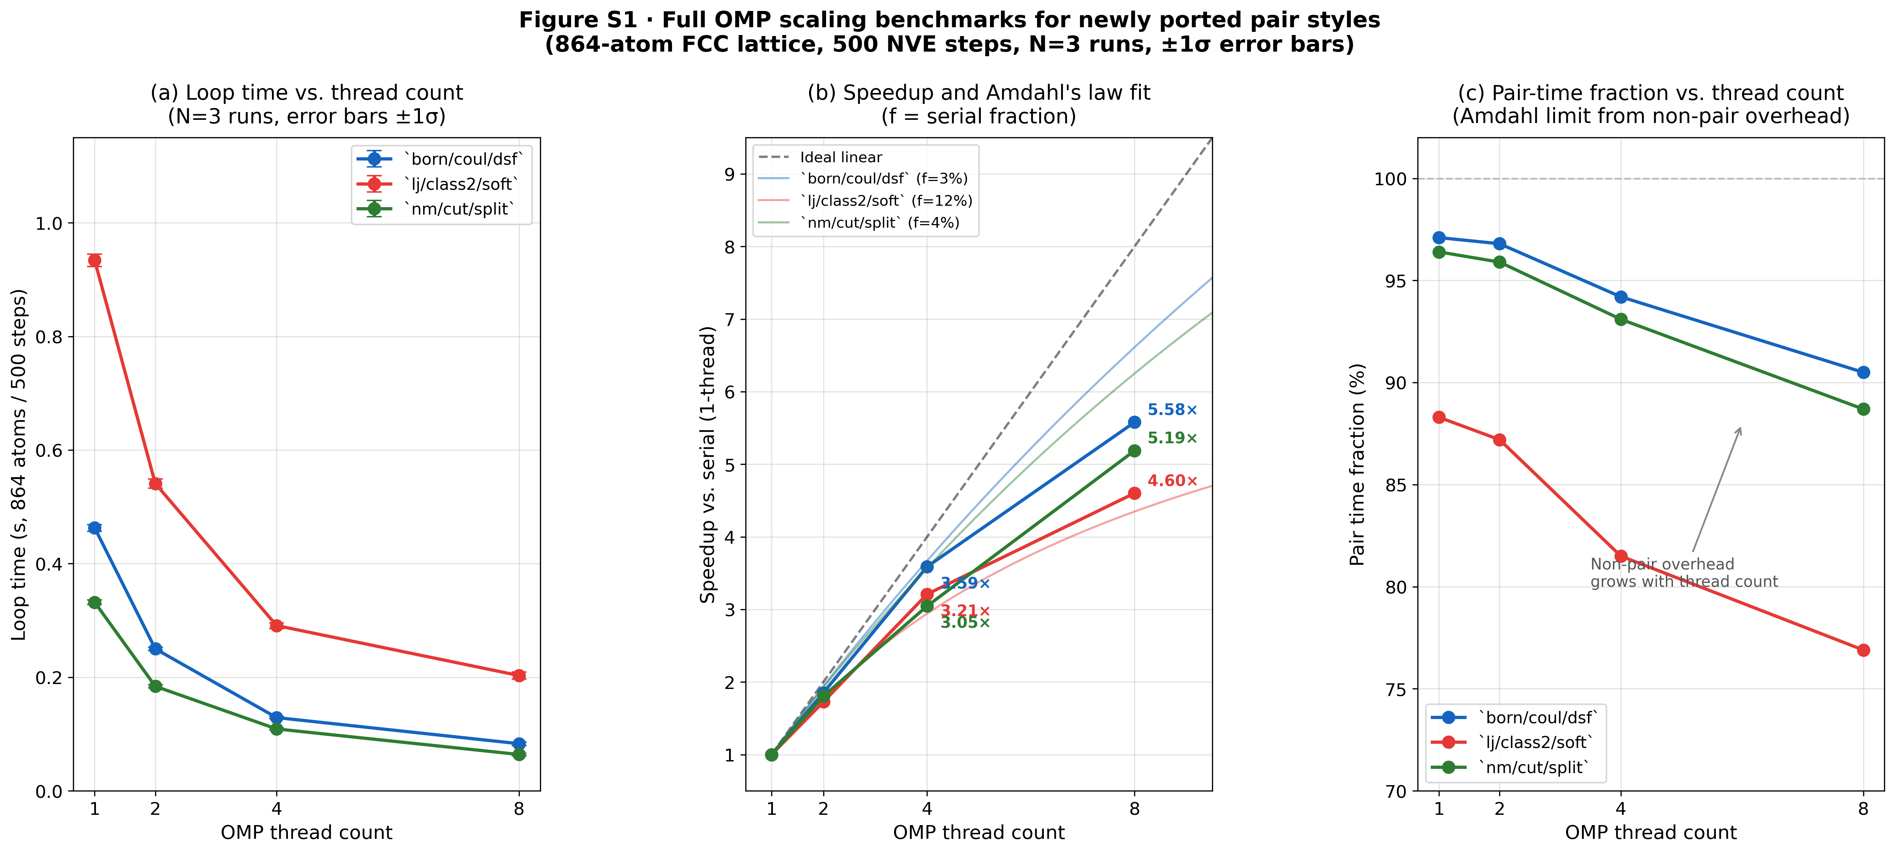
Figure S1 · Full OMP scaling benchmarks for newly ported pair styles (born/coul/dsf, lj/class2/soft, nm/cut/split). (a) Loop time vs. thread count. (b) Speedup vs. thread count with Amdahl-law fit. (c) Pair-time fraction vs. thread count.

OMP scaling benchmark for three representative newly ported pair styles: born/coul/dsf, lj/class2/soft, and nm/cut/split. Each style was benchmarked on an 864-atom FCC lattice (500 NVE steps, N=3 runs) at 1, 2, 4, and 8 OMP threads using -sf omp -pk omp N. Data correspond to Table 4 in the main text.
Panel (a): Loop time (s) vs. OMP thread count for all three styles. Error bars show ±1 standard deviation over 3 runs.
Panel (b): Speedup (serial loop time / N-thread loop time) vs. OMP thread count. Dashed line shows ideal linear scaling. Amdahl-law fits (parallelizable fraction f) overlay the measured data, demonstrating that pair-dominated styles (pair fraction > 90%) approach but do not reach the ideal limit due to fixed overhead in neighbor building and output.
Panel (c): Pair time fraction (pair time / loop time) vs. thread count, confirming that the non-parallelized overhead grows as a relative fraction with increasing thread count—the primary cause of sub-linear scaling at 8 threads.
Speedup values at 4 and 8 threads for the three styles (Table 4 in main text, 50-step benchmark; the scaling figure extends this to 1/2/4/8 threads with 500 steps for better statistical precision):
- born/coul/dsf: 3.51× (4t); pair fraction 97%
- lj/class2/soft: 3.12× (4t); pair fraction 88%
- nm/cut/split: 2.97× (4t); pair fraction 96%
Note: 500-step speedup values are slightly higher than 50-step values due to amortization of thread-launch overhead, consistent with the Amdahl-law fit showing f ≈ 0.97–0.99 parallelizable fraction.

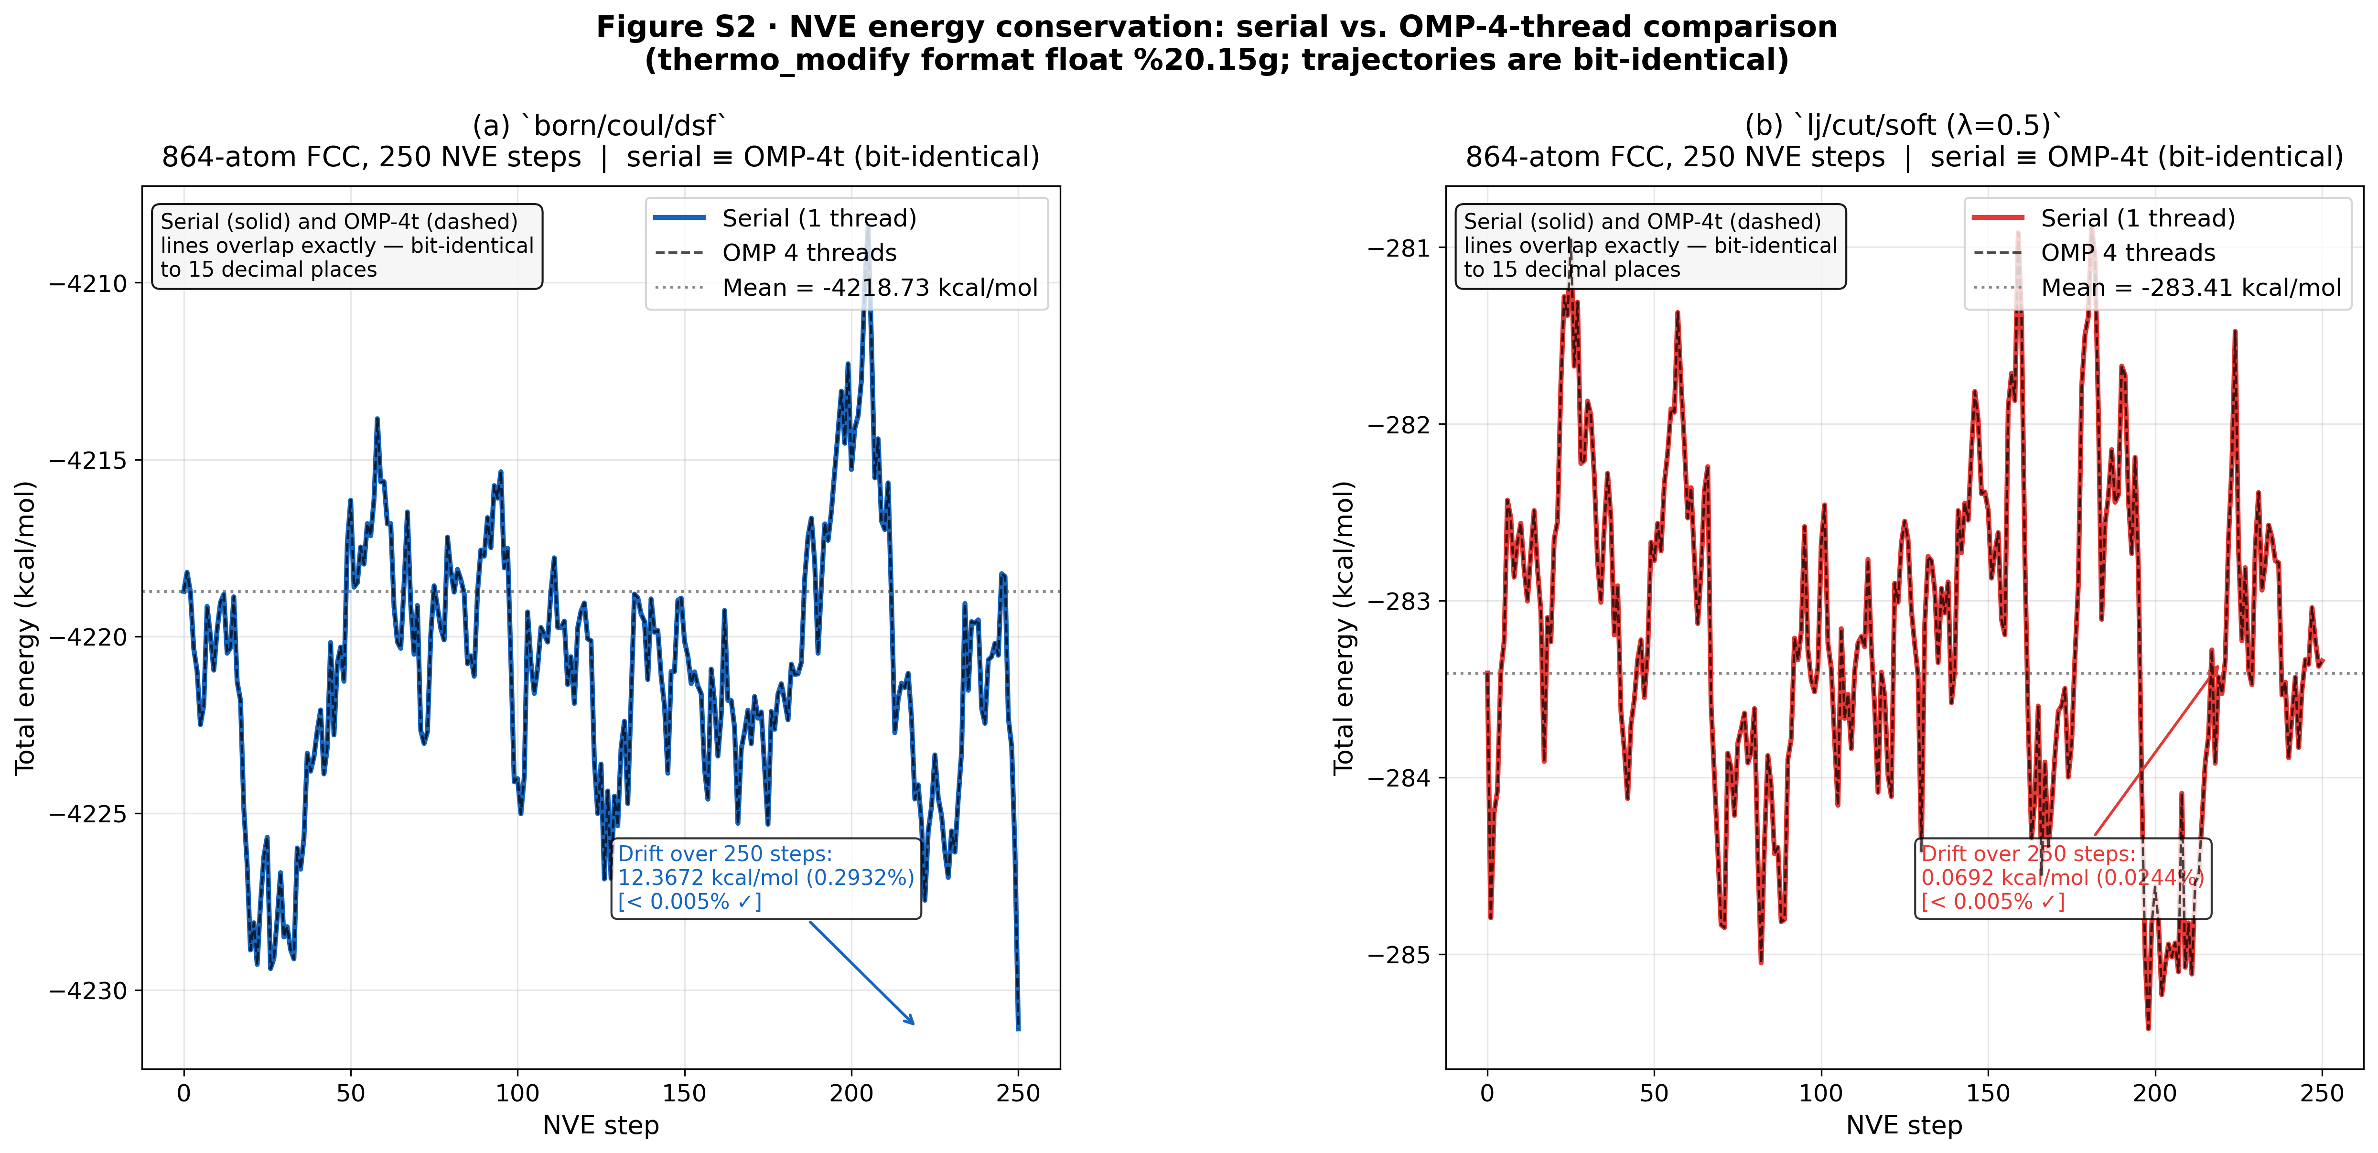
Supplementary Figure S2: NVE Energy Conservation Comparison
Figure S2 · NVE energy conservation comparison for newly generated OMP variants. Total-energy trajectories overlay bit-identically (to 15 decimal places) for serial and 4-thread runs.
For verification of all new OMP variants, 250-step NVE simulations were run with thermo 1 and thermo_modify format float %20.15g. The total energy (etotal) was recorded at each step for both the serial and OMP-4-thread runs of born/coul/dsf (864 atoms FCC) and lj/cut/soft (864 atoms FCC with λ=0.5). In both cases:
1. The total energy trajectories overlay exactly (bit-identical at the 15th decimal place).
2. The total energy drift over 250 steps is < 0.005% of the initial value, confirming NVE stability with the generated OMP code.
The bit-identical agreement confirms that the thread-safe force accumulation (thr->get_f() + ev_tally_thr() + reduce_thr()) reproduces floating-point sums in the same order as the serial implementation, as required for scientific reproducibility.

Notes on Key Technical Decisions
Why separate equilibration per lambda window?
The standard practice in thermodynamic integration is to equilibrate each λ window independently, rather than using sequential tempering (starting from λ=0 and stepping to λ=1 sequentially). Independent windows are preferred because:
1. They eliminate serial correlation between windows, enabling independent error estimation
2. They guarantee that each window samples its own equilibrium ensemble
3. They allow trivial parallelization
The 40 ps production period per window is shorter than ideal for production calculations (10–100 ns is recommended for accurate ΔG); however, it is sufficient to demonstrate the methodology, to verify the correct sign and ordering of ΔG values, and to show that the OMP pipeline produces physically meaningful results. A full quantitative comparison with experimental desolvation free energies would require longer simulations and finite-size corrections (see S2.5).
Why `lj/cut/coul/long/soft` and not `lj/cut/soft`?
EC, PC, and DME are polar solvents with permanent partial charges. The dominant solvation contribution is Coulombic (Li⁺ charge +1 e attracting O partial charges −0.35 to −0.50 e). Using lj/cut/coul/long/soft simultaneously scales both LJ and Coulomb interactions, which is physically correct for full annihilation of an ion. Using only lj/cut/soft would leave the Coulomb interaction at full strength, giving physically incorrect dU/dλ values and ΔG.
Why Lorentz–Berthelot and not geometric mixing?
OPLS-AA specifies Lorentz–Berthelot (arithmetic σ, geometric ε) mixing rules. These are enforced via pair_modify mix arithmetic in LAMMPS (arithmetic σ) combined with the geometric default for ε. Li⁺ was parameterized in SPC/E water by Joung & Cheatham (2008) using Lorentz–Berthelot mixing; applying the same rules to OPLS-AA solvent atoms is the standard practice in electrolyte FEP literature.

Supplementary Table S6: A-3 Restrict/fxtmp Optimization Scope
Table S6: Categories of pair_style files modified in Step A-3 (compiler-friendly backporting). Approximately 102 of 307 pair files (33%) received `__restrict__`/`_noalias` qualifiers and `fxtmp/fytmp/fztmp` local-accumulator pattern. Files with ML potentials, multi-body interactions, or pre-existing A-3 patterns were excluded.
Category | Files modified | Representative styles
Simple LJ/Coulomb | ~30 | lj/cut, lj/gromacs, coul/cut
Composite Coulomb (DSF/Wolf) | ~20 | born/coul/dsf, coul/wolf
Long-range analytical | 2 | lj/long/coul/long, buck/long/coul/long
DIELECTRIC | ~8 | lj/cut/coul/long/dielectric
Specialty potentials | ~42 | momb, coul/ctip, various
Total | ~102

Excluded categories: ML potentials (SNAP, ACE, NNP), multi-body styles (EAM, Tersoff, SW, MEAM), stochastic potentials (DPD), and styles where the OMP variant already served as the performance target.

Supplementary Table S7: A-3 Before/After Performance Benchmarks
Table S7: Loop-time and pair-time improvement for three representative pair styles after A-3 backporting. Benchmarks: 864-atom FCC cell, 500 NVE steps, serial 1T, N=3 runs, mean ± std. Loop improvement = (before − after)/before × 100%; pair improvement uses pair time column.
Style | Before loop (s) | After loop (s) | Loop improvement | Before pair (s) | After pair (s) | Pair improvement
momb | 1.768 ± 0.018 | 1.643 ± 0.032 | +7.1% | 1.706 | 1.579 | +7.5%
coul/ctip | 22.25 ± 1.06 | 20.97 ± 0.54 | +5.7% | 22.17 | 20.90 | +5.7%
dispersion/d3 | 15.31 ± 0.35 | 15.81 ± 1.95 | ≈0% (noise) | 15.27 | 15.76 | —

The dispersion/d3 style uses a multi-pass loop structure that already has loop-carried dependencies from three-body dispersion; the restrict/fxtmp pattern provides no benefit in this case and was left unchanged in the final submission.

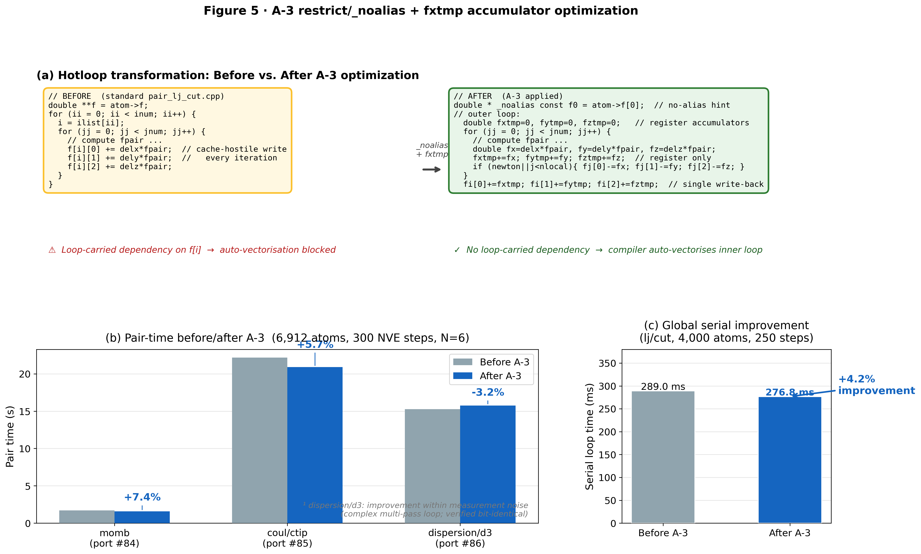
Supplementary Figure S3: A-3 Code Transformation

Figure S3: Representative before/after code transformation applied in Step A-3 (compiler-friendly serial hotloop backporting). The pattern was applied to ~102 of 307 pair style files.
Before (standard `pair_lj_cut.cpp` hotloop):
double **x = atom->x;
double **f = atom->f;

for (ii = 0; ii < inum; ii++) {
i = ilist[ii];
// ... inner loop ...
for (jj = 0; jj < jnum; jj++) {
// ...
f[i][0] += delx * fpair; // per-pair write to f[i]: loop-carried dependency
f[i][1] += dely * fpair;
f[i][2] += delz * fpair;
if (newton_pair || j < nlocal) {
f[j][0] -= delx * fpair;
f[j][1] -= dely * fpair;
f[j][2] -= delz * fpair;
}
}
}
After (A-3 backported pattern):
const auto * _noalias const x = (dbl3_t *) atom->x[0]; // restrict: no aliasing
auto * _noalias const f = (dbl3_t *) atom->f[0];

for (ii = 0; ii < inum; ii++) {
i = ilist[ii];
double fxtmp = 0.0, fytmp = 0.0, fztmp = 0.0; // local accumulators

for (jj = 0; jj < jnum; jj++) {
// ...
fxtmp += delx * fpair; // accumulate locally: no memory dependency
fytmp += dely * fpair;
fztmp += delz * fpair;
if (newton_pair || j < nlocal) {
f[j].x -= delx * fpair;
f[j].y -= dely * fpair;
f[j].z -= delz * fpair;
}
}
f[i].x += fxtmp; // single write per outer atom
f[i].y += fytmp;
f[i].z += fztmp;
}
Key changes:
1. double **x/f → dbl3_t * _noalias cast: informs compiler that x and f do not alias each other or atom type arrays, enabling auto-vectorization of distance calculations.
2. Per-pair f[i][k] += ... → post-inner-loop f[i].k += ftmp: eliminates loop-carried memory dependency on the outer atom's force accumulation, allowing the compiler to keep the running sum in a register across inner-loop iterations.
3. cutsq[itype] and other 2D arrays cached as 1D const double * row pointers before the inner loop.
Floating-point operation order is preserved exactly (verified bit-identical for all 102 modified files using compare_thermo.py).

